To

Gaolan Port

From

Han Zhou

Copy to

Li Zhou, Yusen Chen

Subject

Outcomes of the meeting on the Gaolan Port Material Flow and Platform April 2017

**Attendants**:

Port of Gaolan: Mr. Huang

GDCERCU: Ms. Yang

TNO: Han Zhou, Ton Bastein

**Agreed actions**:

* Action 1: Mr. Huang would send data about chemical plants present in the Gaolan Port and on the processes that are operated in these plants. A list of companies has been received by TNO and the information contains will be used to give direction to the processes to analyse.
* Action 2: TNO will give an overview of different options for the tool to be developed. These have been described in the next section, together with what has already been prepared until right now.

**Summary of the Tool and Platform**

This tool is specially developed for Gaolan Port, Zhuhai, China. It is for material flow modeling and analysis. The tool will help Gaolan port to evaluate the petrochemical chain to screen different scenarios for extension of the Gaolan petrochemical complex that adds most value (added value of products) and that does not result in large additional emissions. A screenshot of the platform is given below.

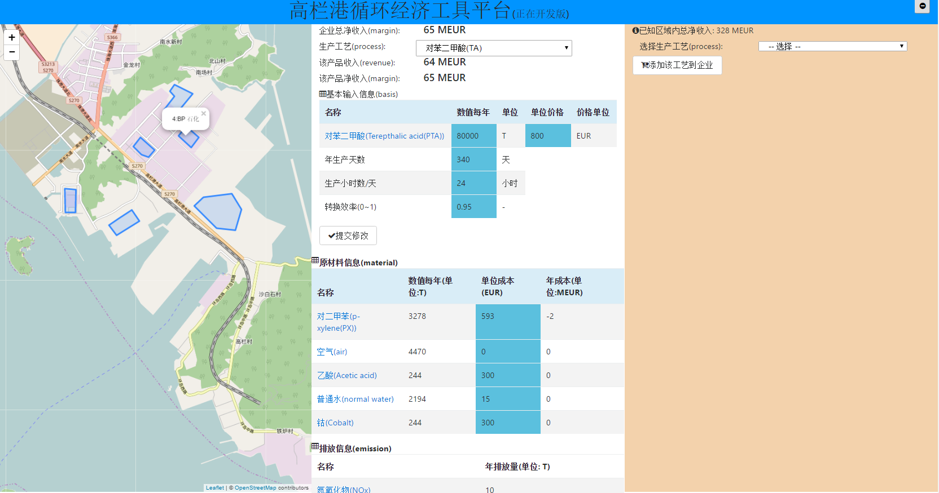

Picture of the Gaolan Port Material Flow and Platform.

The tool has been demonstrated and feedback has been received. Based on that feedback work has progressed. With this document we would like to give an overview of the current status. We wrote also a more detailed document about what can be done with the tool and how it can be used. That document is included as Annex.

A large piece of work has been carried out, especially for the programming of the tool. Coming period we plan to include the chemical engineering knowledge in the tool that is currently been researched..

In the last couple of months much time has been invested in this project by the project team. When the tool programming and the chemical engineering knowledge are bundled we will have fully deployed our project budget.

Also, we defined a number of optional functions that can be included in the tool but that are not part of the project. These are listed in the end of this document.

## *Functions existing*

* Display per plant information about processes, products, feedstock, primary energy use and emissions.

**Data required:** spatial location of the plant, specific processes carried out in the plant, product name(s) and capacity

*(in the model* ***default numbers are calculated by TNO, which may be used as benchmark****)*

* Display the impact of capacity increase of a chemical product on the revenues and emissions. Additionally, the changes in the amount of energy and feedstock will also be reflected. The impact are both for plant level and site level.

*E.g. Increase in capacity of the process to produce mono ethanol amine (MEA) from 100 kT/year to 200 kT/year will show an increase in added value and on emissions for this specific process on the block level but also show/remark on the impact on the preceding process producing the feedstock ethylene oxide (EO)*

* Display changes on the plant and changes on the whole site after adding defined processes to existed plants.
* Highlight on the map the plants producing a selected product or supplying the selected material. It shows a (potential) connection between plants
* Edit the existed chemical compounds or insert new compounds into the platform tool.
* Add new chemical process. This enables the introduction of locally collected data on mass flows, reaction efficiency, energy use and emission data etc. (TNO has already created a few process blocks based on the company information provided by Gaolan Port.)

## Optional functions (work outside the contract)

* Create new plant by drawing a polygon on the map, then add process(es) to them, in order to simulate the situation after a new plant is working in Gaolan site. After addition, the potential whole material flow change in the site will be displayed.
* Visualize the whole site description quantitatively, so that to show to (potential) plants.

**Data required: whole site related data including locations**

* Visualize the petrochemical processes connected through main feedstock / main product mass streams in a chart, in order to have an overview of the processes using those compounds.
* Visualize energy change/recycling, to identify energy-related issues
* (Virtual reality (no actual functions implementations)
* A comparison of emissions and revenues for different chemical products.